# Technical Career Education Private Limited

5th floor, Sahyadri Campus, Adyar, Mangalore 575007



# Full Stack Development Skill Lab Course

**PROJECT REPORT**

# 2023 - 24

**Project Title: ‘Food Delivery’**

Submitted by:

SWASTHIK B 4SF23CS226

SHIVANANDA 4SF23CS205

SACHIN HH 4SF23CS178

MITHUN OMPRAKASH 4SF23CS108

GIRISH NAIK 1065/CS/2023-24

Institution:



# Sahyadri College of Engineering and Management

Adyar Mangalore 575007

# CONTENTS

**Project Overview**

1. **Introduction**
2. **Problem Statement**
3. **Solution**
   1. System requirements for the project.
   2. Flowchart of the project.
   3. Frontend
   4. Backend
4. **Conclusion/Outcome:**
5. **Reference List**

# Project Overview

|  |  |  |
| --- | --- | --- |
| Problem Statement | FOOD DELIVERY | |
| Solution Proposed *(video Link)* |  | |
| Link to the final Challenge presentation |  | |
| Link to photos/ videos drive |  | |
| Class/ Section | 3 C | |
| Team Name | ROCKSTARS | |
| Team Members | Name | USN |
|  | SWASTHIK B | 4SF23CS226 |
|  | SHIVANANDA | 4SF23CS205 |
|  | SACHIN HH | 4SF23CS176 |
|  | MITHUM OMPRAKASH | 4SF23CS108 |
|  | GIRISH NAIK | 1065/CS/2023-24 |

## Introduction

In today’s fast-paced world, the food service industry is increasingly moving towards digital solutions to improve customer experience, streamline operations, and increase efficiency. The **Food Business Website** aims to address these challenges by providing a user-friendly, responsive platform built using modern web technologies like **React.js**. The primary goal of this project is to create an interactive and efficient website where customers can easily browse the menu, customize their orders, and provide feedback. Additionally, the platform empowers administrators with the tools to effectively manage the menu, handle customer orders, and perform essential CRUD (Create, Read, Update, Delete) operations.

The front-end application, designed using **React.js**, ensures a dynamic and responsive user interface, offering a seamless experience across various devices. By leveraging the power of React, the platform can provide real-time updates and interactions without the need for page reloads, thereby enhancing the user experience. Through a clean and intuitive layout, users can quickly navigate through the menu, customize their selections, and place orders with minimal effort.

For the administrative side, the platform includes an **Admin Dashboard** that enables administrators to easily manage the menu, monitor orders, and review customer feedback. The dashboard features **CRUD functionality** for menu management, allowing administrators to add, edit, or remove menu items. Additionally, the order management system helps track customer orders, update statuses, and manage feedback, providing the flexibility needed to run a smooth and efficient food business.

By incorporating features such as order customization, real-time feedback, and efficient menu management, the website improves customer satisfaction while streamlining internal operations. This report provides a comprehensive overview of the design, development, and features of the Food Business Website, highlighting the core technologies used and the challenges overcome during the project development.

## Problem Statement

The **Food Business Website** seeks to address the growing demand for digital solutions in the food service industry, where both customer experience and operational efficiency are critical to business success. The problem at hand is the need for a **responsive, user- friendly platform** that simplifies the entire food ordering process for customers while providing powerful tools for administrators to manage and optimize business operations. For **customers**, the website should provide a seamless experience where they can browse through a variety of menu items, customize their orders (such as choosing toppings, sizes, or ingredients), and easily place their orders for delivery or pickup. In addition, customers should be able to leave feedback, which can be used to improve services and products.

This aspect of customer interaction is crucial in building loyalty and gaining insights into customer preferences and satisfaction levels.

On the **administrator side**, the website should enable the efficient management of the menu and orders. Administrators should be able to perform **CRUD (Create, Read, Update, Delete) operations** on menu items, allowing them to add, update, or remove dishes based on availability or changing customer preferences. Furthermore, the admin interface should include a real-time order management system, allowing administrators to track the status of customer orders, process them, and update their statuses (e.g., pending, preparing, completed). Another critical aspect is **customer feedback management**, where admins can review and respond to feedback, ensuring high service standards and continuous improvement.

The use of **React.js** as the primary frontend technology ensures that the website is highly interactive, fast, and responsive. React's component-based architecture allows for the development of reusable UI components, making the website scalable and easier to maintain. The platform will be designed to work smoothly across a variety of devices, including desktops, tablets, and smartphones, making it accessible to a wide audience.

By addressing these requirements, the **Food Business Website** aims to:

Enhance the **customer experience** by offering an intuitive and interactive interface for browsing, customizing, and ordering food.

Improve **operational efficiency** for administrators by providing an easy-to-use system for managing the menu, tracking orders, and handling feedback.

Streamline the food ordering process, reducing friction for customers while enabling businesses to operate smoothly and effectively.

Ultimately, this solution will provide a modern, digital platform for food businesses to enhance both their customer engagement and internal operations, while offering a reliable and scalable solution to meet the evolving demands of the industry.

## Solution :

* 1. **System Requirements for the Project**

For the **Food Business Website**, the following tools, technologies, and services will be required:

**Frontend:**

1. **React.js** - A JavaScript library for building user interfaces, which will enable dynamic rendering of components and enhance user experience.
2. **React Router** - For handling navigation and routing between different pages of the website (Home, Menu, Cart, Admin Dashboard, etc.).
3. **HTML** - To make HTTP requests to the backend for fetching data (menu items, orders, feedback) and sending order information.
4. **Node.js & npm** - Node.js will be used as the JavaScript runtime environment, and npm will be used for managing project dependencies.

|  |  |  |
| --- | --- | --- |
| 5. | **CSS/SCSS or Styled-Components** - For styling the components and making the  responsive. | UI |
| 1. | **Backend (If implementing full-stack):**  **Node.js** - Backend framework for handling requests and routing. |  |
| 2. | **Express.js** - A web framework for Node.js, making it easier to build RESTful APIs. |  |
| 3. |  |  |
|  | **3.2 Flowchart of the Project**  Here is a simplified flowchart of the **Food Business Website**: sql  Copy code  + + |  |

| Start (Home Page) |

+ +

| v

+ +

| Browse and Select Menu Items |

+ +

| v

+ +

| Customize Order (Add to Cart) |

+ +

| v

+ +

| Proceed to Checkout (Review Order) |

+ +

| v

+ +

| Order Confirmation and Feedback |

+ +

| v

+ +

| Admin: Manage Menu, Orders, |

| Feedback (CRUD Operations) |

+ +

| v

+ +

| End (Logout) |

+ +

**Explanation:**

* **Start (Home Page)**: The user starts by visiting the homepage of the website. They are presented with options to browse the menu or log in if they are an admin.
* **Browse Menu**: Users can browse through the food menu, view the details of the items, and add them to the cart.
* **Customize Order**: Users can customize their order by selecting different options (size, toppings, etc.).
* **Proceed to Checkout**: After adding items to the cart, the user proceeds to the checkout page, where they review their order and enter necessary details.
* **Order Confirmation and Feedback**: After confirming the order, the user receives a confirmation and can provide feedback on their experience.
* **Admin Panel**: Admins can log into the admin dashboard, manage the menu, view orders, and respond to customer feedback.

**3.3 Frontend**

**Steps for Frontend Development:**

1. **Set up React Project**:
   * Install React using Create React App: bash

Copy code

npx create-react-app food-business-website cd food-business-website

1. **Install Required Dependencies**:
   * Install React Router, Axios, and Material-UI (if needed): bash

Copy code

npm install react-router-dom axios @mui/material @emotion/react @emotion/styled

1. **Structure of the Project**:
   * Create folders and files for components and pages: mathematica

Copy code src/

├── components/

│ ├── Navbar.js

│ ├── MenuItem.js

│ └── CartItem.js

├── pages/

│ ├── HomePage.js

│ ├── MenuPage.js

│ ├── CartPage.js

│ ├── CheckoutPage.js

│ └── AdminDashboard.js

├── services/

│ └── api.js

├── App.js

└── index.js

1. **Review :**

<div className="box" key={index * Math.random()}>

<img src={qouteImg} alt="" className="quote" />

<p>

Balancing sweet, sour, salty, bitter, and umami flavors makes food special. Many cuisines have signature flavor combinations, like the spice blends in Indian food or the umami-rich ingredients in Japanese dishes.

</p>

<img src={item.img} className="user" alt="" />

<h3>john deo</h3>

<div className="stars">

<i className="fas fa-star"></i>

<i className="fas fa-star"></i>

<i className="fas fa-star"></i>

<i className="fas fa-star"></i>

<i className="fas fa-star-half-alt"></i>

</div>

</div>

))}

</div>

</section>

</>

);

};

export default App;

5. **Analyzation:**

import React from "react";

import AboutImg from "../assets/images/about-img"; const About = () => {

return (

<>

<section className="about" id="about">

<h1 className="heading">

<span>about</span> us

</h1>

<div className="row">

<div className="image">

<img src={AboutImg} alt="" />

</div>

<div className="content">

<h3>what makes our food special?</h3>

<p>

Local and seasonal ingredients contribute to the uniqueness of a dish. For example, a mango dessert in India during the summer tastes special because of the richness of the fruit grown in the region.

</p>

<p>

Food reflects the traditions and history of a community or region. Recipes passed down through generations carry cultural significance and often tell a story about the people who created them.

</p>

<a href="#" className="btn"> learn more

</a>

</div>

</div>

</section>

</>

);

};

export default About; export default MenuPage;

**3.4 Backend**

**Steps for Backend Development:**

1. **Set up Backend with Node.js**:
   * Initialize a new Node.js project: bash

Copy code

mkdir food-business-backend cd food-business-backend npm init -y

npm install express mongoose cors body-parser bcryptjs jsonwebtoken

1. **Set to Menu**:

import React from "react"; import { menu } from "../Data"; const Menu = () => {

return (

<>

<section className="menu" id="menu">

<h1 className="heading"> our <span>menu</span>

</h1>

<div className="box-container">

{menu.map((item, index) => (

<div className="box" key={index * Math.random()}>

<img src={item.img} alt="" />

<h3>tasty and healty</h3>

<div className="price">

2500/-<span>2000/-</span>

</div>

<a href="#" className="btn"> add to cart

</a>

</div>

))}

</div>

</section>

</>

);

};

export default Menu;

1. **Define Menu Schema and Routes**: import React from "react";

import { review } from "../Data";

import qouteImg from "../assets/images/quote-img.png"; const Review = () => {

return (

<>

<section className="review" id="review">

<h1 className="heading"> customer's <span>review</span>

</h1>

<div className="box-container">

{review.map((item, index) => (

<div className="box" key={index * Math.random()}>

<img src={qouteImg} alt="" className="quote" />

<p>

Balancing sweet, sour, salty, bitter, and umami flavors makes food special. Many cuisines have signature flavor combinations, like the spice blends in Indian food or the umami-rich ingredients in Japanese dishes.

</p>

<img src={item.img} className="user" alt="" />

<h3>john deo</h3>

<div className="stars">

<i className="fas fa-star"></i>

<i className="fas fa-star"></i>

<i className="fas fa-star"></i>

<i className="fas fa-star"></i>

<i className="fas fa-star-half-alt"></i>

</div>

</div>

))}

</div>

</section>

</>

);

};

1. **Conclusion/Outcome**

he **Food Business Website** project successfully addresses key operational and customer experience challenges faced by the modern food service industry. With an intuitive and responsive design built on **React.js** for the frontend, and **Node.js** and **Express.js** for the backend, this platform brings together the latest web development technologies to create an efficient solution that enhances both the customer-facing side of the business and the internal management processes.

On the **customer side**, the website allows for seamless browsing of the menu, customizable orders, and easy order placement, all backed by a smooth, fast, and interactive user interface. Features like order customization, real-time cart updates, and customer feedback management ensure that users have a positive and engaging experience. The responsive design ensures that customers can access the platform and complete their orders effortlessly across various devices—whether on desktops, tablets, or smartphones.

From an **administrator's perspective**, the backend provides an efficient and intuitive system for managing the menu, tracking orders, and reviewing customer feedback. The implementation of **CRUD operations** for managing menu items gives administrators the flexibility to update their offerings, remove outdated items, or add new ones based on availability or customer preferences. Additionally, the system supports order management, allowing administrators to track, update, and process orders in real-time, leading to improved operational efficiency and customer satisfaction.

A major focus of the project was on **security and scalability**. The use of **JWT (JSON Web Tokens)** for admin authentication ensures secure login and access to sensitive parts of the website, such as the admin dashboard. By leveraging **MongoDB** as the database, the system is built to scale easily as the business grows, with flexible schema design to handle varied menu items, orders, and customer feedback. Furthermore, the use of **Axios** allows

seamless communication between the frontend and backend, ensuring that the data flow between components is both smooth and efficient.

The **React.js** architecture enables a dynamic, component-driven approach, making the website highly maintainable and scalable. It also supports the rapid development of new features and functionalities as the business evolves. The **Redux** or **Context API** for state management ensures a consistent and reliable user experience across all pages, particularly when handling the cart, orders, and admin data.

In addition to these technical aspects, this platform also promotes **customer loyalty and engagement**. By allowing customers to provide feedback on their orders and their overall experience, the website fosters an environment where businesses can continuously improve their services based on real customer input. This feedback loop is vital for any business looking to enhance its offerings and maintain high customer satisfaction levels.

Ultimately, this project has achieved its objective of creating a **modern, efficient, and user-friendly food business website** that simplifies the ordering process for customers while streamlining operations for administrators. The platform is designed with the flexibility to grow and adapt to future needs, whether it’s adding new features, expanding the menu, or handling an increasing number of orders.

In conclusion, the **Food Business Website** offers a robust, scalable solution that meets the current demands of the food industry while providing room for future growth. It stands as an example of how technology, when implemented thoughtfully, can improve business operations and create a better experience for both customers and administrators. This solution is well-suited for small to medium-sized food businesses looking to modernize their operations and provide an enhanced service to their customers. With its combination of advanced frontend technologies, secure backend processes, and a focus on usability, this project is poised to drive success in the competitive food service industry.

## References:

**Frontend Development (React.js, Routing, State Management)**

1. **React Documentation**: https://reactjs.org/docs/getting-started.html
2. **React Router Documentation**: <https://reactrouter.com/>
3. **Redux Documentation** (for state management): https://redux.js.org/

**Backend Development (Node.js, Express, Database, Authentication)**

1. **Node.js Documentation**: https://nodejs.org/en/docs/

**General Web Development Resources**

1. **MDN Web Docs (CSS, JavaScript)**: <https://developer.mozilla.org/>
2. **Postman Documentation** (for testing APIs): https:/[/www.postman.com/docs/](http://www.postman.com/docs/)
3. **Create React App Documentation**: https://reactjs.org/docs/create-a-new-react-app.html

These resources will provide further insights and tutorials on how to build, manage, and scale a web application with the technologies mentioned in the solution.

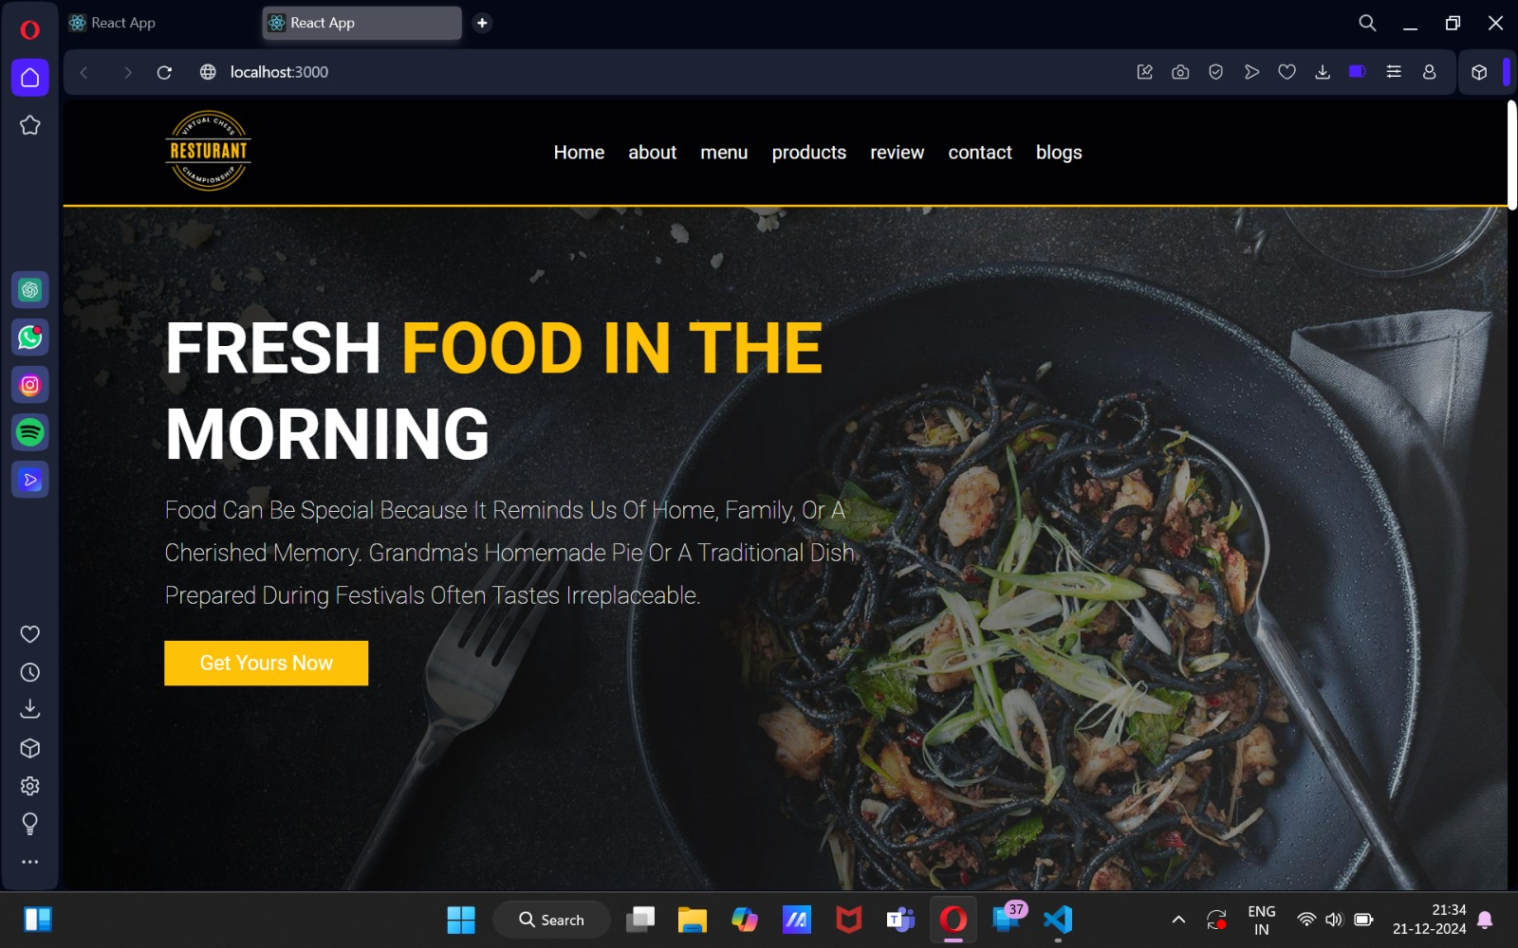

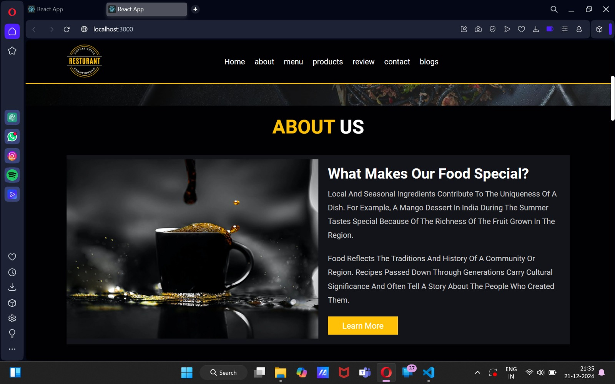

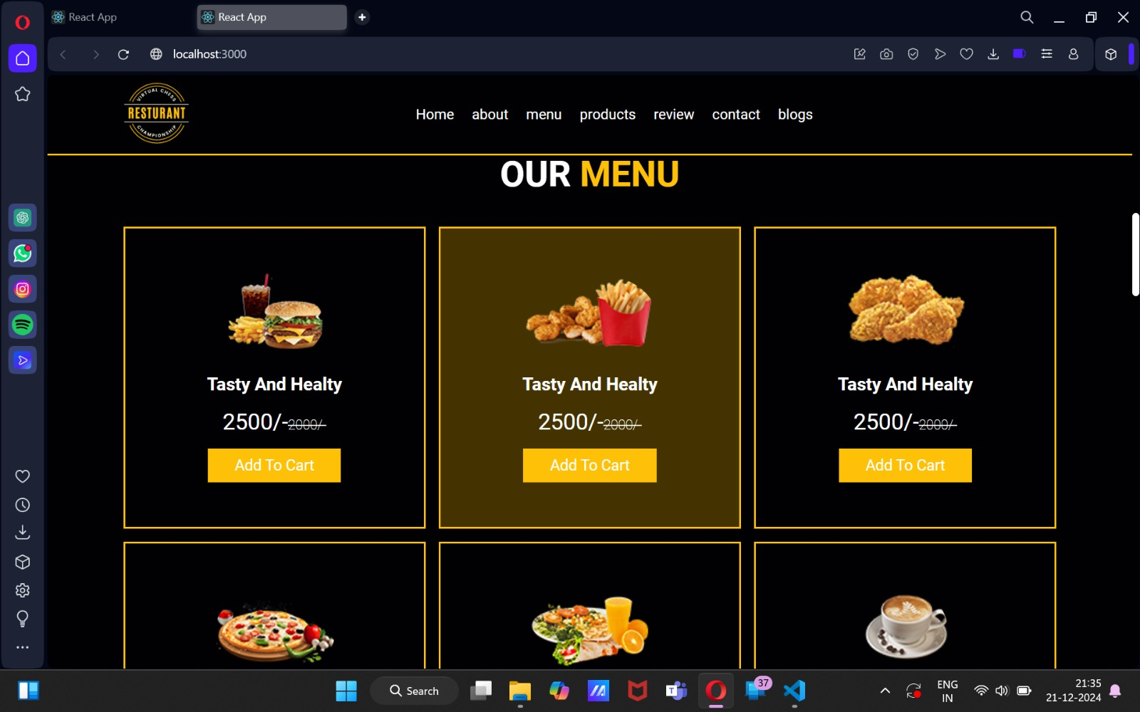

Git-Hub links :

<https://github.com/Swasthik-63/Food.com.git>

<https://github.com/shiva-kkd/cake-shop1.git>

<https://github.com/sachinhh/milestone2.git>

<https://github.com/MithunOP/foodwebsite.git>

<https://github.com/girishnaik1234/foodwebsite.git>